Practical 2 | State Management and Routing in React
Objective | To implement reactive state management using useState and multi-page navigation using React Router in the existing portfolio application.
Problem  Statement | - Extend the portfolio application from Practical 1 by adding React Router.  - Implement a navigation bar with at least 3 routes: Home, Projects, and Contact.  - Each route must render a distinct component without a full page reload. • Add at least 2 useState variables used meaningfully one for toggling UI visibility and one for managing a form input on the Contact page.  - The Contact page must include a controlled input that captures and displays user input in real time.
Output | 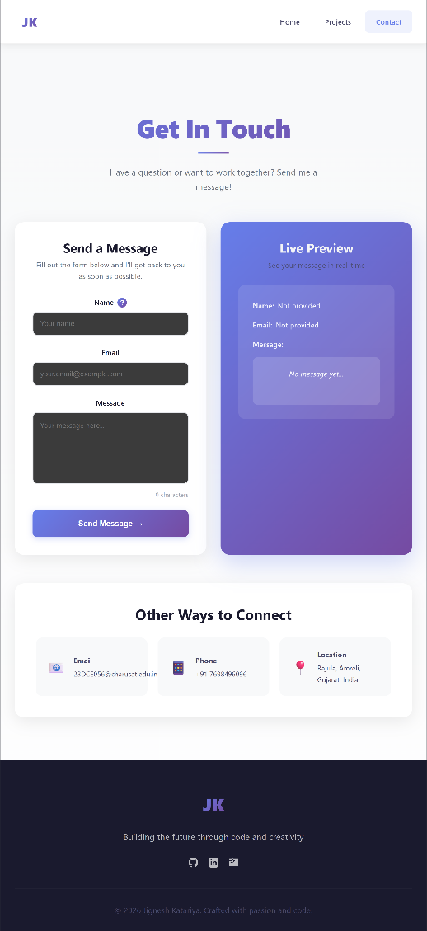  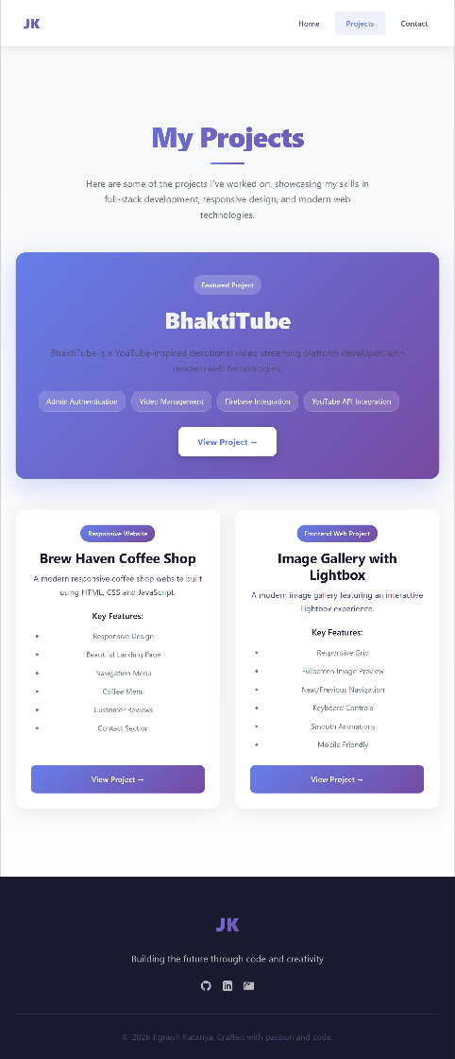

Key Questions  / Analysis | - What is the role of each component in the overall UI structure?  Each component is responsible for a specific part of the UI, making the application modular, organized, and easy to maintain.  - How does React re-render when props change?  When props change, React updates the Virtual DOM, compares it with the previous version, and re-renders only the affected components.  - Why is component reusability important in large-scale applications? Reusable components reduce code duplication, improve consistency, simplify maintenance, and speed up development.
Supplementary  Problems |   Implement a dark/light mode toggle using useState that applies a CSS class to the root element.  Store the contact form input in state and display a live character count below the input.  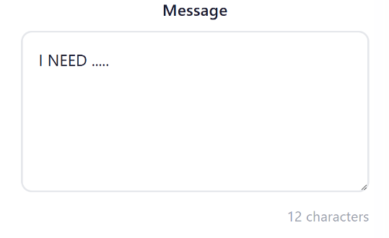
Key Skills  Addressed | - Installing and configuring React Router v6  - Defining and navigating between routes without page reload  - Managing component state using the useState hook  - Building controlled form inputs tied to state
Learning  Outcome | Students will be able to implement client-side routing with React Router and manage dynamic UI state using useState, resulting in a multi-page application without full page reloads.

